

TechRevolution 2.0 Transfer Network

**Transnational meeting, Novska, 24th - 25th November 2021**

**REGISTRATION FORM**

**Please send the registration form to:** [tena.fabijanic@novska.hr](mailto:tena.fabijanic@novska.hr)

|  |  |  |
| --- | --- | --- |
| ***First Name :*** |  | |
| ***Family Name :*** |  | |
| ***Organization:*** |  | |
| ***Position:*** |  | |
| ***Position in TechRevolution 2.0*** | Project Coordinator  ULG coordinator  Expert Other………………………………. | |
| ***e-mail address :*** |  | |
| ***Phone and/or mobile number :*** |  | |
| ***Please indicate do you hold a current COVID-19 EU vaccination pass/ certificate .*** | YES  No | |
| ***Due to limited accommodation options please reply:***   * Would it be acceptable if you share a room with a colleague from your city? YES / NO * Would it be acceptable if you share an apartment with a colleague from your city? YES / NO | | |
| ***Dates of arrival and departure*** | | |
| **Arrival**  Day :  Time : | | Departure Day :  Time : |
| Dietary requirements: | | |
| Vegetarian/Vegan  Food Intolerance: ________________________________________  Other food – related comment: ________________________________ | | |
| Other comments or needs: | | |

**Important Covid Travel information:**

**All people traveling into Croatia need to comply with one of these criteria:**

**Passengers coming directly from the countries and/or regions of the European Union, i.e. countries and/or regions of the Schengen area and Schengen associated countries**, regardless of their citizenship, will be allowed entry into the Republic of Croatia if they possess a valid EU Digital COVID Certificate.  
  
Exceptionally, passengers arriving directly from the countries and/or regions of the European Union, i.e. countries and/or regions of the Schengen area and Schengen associated countries, who do not yet possess an EU Digital COVID Certificate, will be allowed entry into the Republic of Croatia if they have the following:

* **negative PCR test result or [rapid antigen test result - RAT](https://mup.gov.hr/uzg-covid/hrvatski/286211" \l "BAT)** for SARS-CoV-2, where the RAT test must be listed in the [Common list of rapid antigen tests recognized by the Member States of the European Union](https://ec.europa.eu/health/sites/default/files/preparedness_response/docs/covid-19_rat_common-list_en.pdf), published by the European Commission. If the **RAT** test results were made abroad, the manufacturer and/or the commercial name of the test must be visible. Otherwise, it will not be accepted as credible for entering the Republic of Croatia.  The PCR test result must not be older than 72 hours and the RAT test result must not be older than 48 hours, counting from the time the test was taken until the arrival at the border crossing point;
* **certificate that they have received two doses of vaccine**used in the EU Member States (Pfizer, Moderna, AstaZeneca, Gamaleya, Sinopharm) **not older than 365 days**, or a certificate that they have received **one dose of the vaccine if the vaccine is administered in a single dose (Janssen/Johnson&Johnson) not older than 365 days, provided that 14 days have passed since they received the single dose;**
* **certificate showing that they have received the first dose** of the Pfizer, Moderna or Gamaleya vaccine, on the basis of which they can enter the Republic of Croatia in the period of 22 to 42 days from receiving the vaccine, or 22 to 84 days from receiving the first dose of the AstraZeneca vaccine;
* **certificate showing that they have recovered from COVID-19 and have received one dose of vaccine** within eight months from contracting the disease, provided that the vaccine was administered less than 12 months from their arrival at the border crossing point;
* positive PCR test result or [rapid antigen test result,](https://mup.gov.hr/uzg-covid/hrvatski/286211" \l "BAT) confirming that the holder recovered from the SARS-CoV-2 virus infection, which was performed in the previous 365 days and which is older than 11 days from the date of arrival at the border crossing point, or  a medical certificate of recovery;
* **or if they perform PCR testing or [rapid antigen testing - RAT](https://mup.gov.hr/uzg-covid/hrvatski/286211" \l "BAT) for SARS-CoV-2**immediately upon their arrival in the Republic of Croatia (at their own expense), with the obligation to stay in self-isolation until they obtain a negative test result. In case they cannot get tested, they have to self-isolate for ten (10) days.

**Another important links about Covid travel information:**

* [**https://mup.gov.hr/uzg-covid/english/286212**](https://mup.gov.hr/uzg-covid/english/286212)

[**https://www.koronavirus.hr/en**](https://www.koronavirus.hr/en)

**Transport from Zagreb airport**

Considering there is no public transport from the Airport Zagreb to City of Novska, we suggest we take care about private transport.

You will get a bill and you will be able to pay in cash (HRK) so there would be no problem.

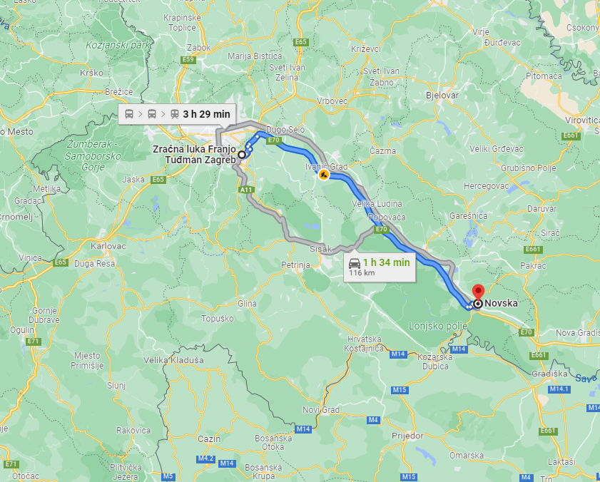

**Accommodation**

As we are small city, unfortunately there are no hotels in or around the city.

We would suggest private accommodation, but first we need to know how many people is coming and what are your wishes and needs regarding accommodation.

Can you share a room with colleague?

We would first like to have all the information about that, so we can dedicate to seeking accommodation.

If you will be located outside the city, we will take care of transportation to Novska, and also in the evening to your accommodation.

**Local currency:**

The Croatian currency is the Kuna (HRK).

You will find that you can pay for some items – private accommodation, taxis, some small  
restaurants – in Euros. Do note that this is entirely on an unofficial basis; the Euro is NOT an  
official currency and NO business/individual is required to accept them as payment.

Taking your ‘home’ currency to Croatia and changing it here will not result in any problem.  
You can exchange your money in a bank or in one of numerous Bureaux de Change dotted  
around the city, also on the airport. We suggest that you have our local currency.

You will also find ATM's right on the airport and in the city as well.

# 